Crypto in Retirement Plans? Come on…..

They say that if you follow the history of baseball that it reflects what’s happening in America. It’s funny, no one ever says anything like that about the retirement plan industry, but then again, most people don’t even know that retirement plans are an industry! I can make a case that retirement plans do, in fact, have a broader tie in to what’s happening in the country at large. Today, we have more women and minorities working in our space and many industry groups have formed to promote equality in our industry. Similarly, just as Environmental and Social change have become forefront, ESG funds have also become topical in retirement plans. So, like baseball, retirement plans can also be used as a mirror reflection of what’s happening in the country around us.

If the above is my thesis, the next part is another example which is Cryptocurrency (Crypto) in retirement plans??? So, yes, just as Bitcoin and all the other varieties are becoming more and more mainstream, naturally, people who view these as investable opportunities want them to be available where their money is, which for a lot of people is in retirement plans. Within the last few years, there has been a small number of very noisy providers responding to this demand which has now “forced” the Employee Benefits Security Administration (EBSA), an agency inside of the Department of Labor to take a position on Crypto as a potential investment for retirement plans. The result, Compliance Assistance Release 2022-01 in March of this year.

The reader can read all about it in the above link. If we had to summarize what we see in this C.A.R. it’s basically a cautionary release. There’s not a lot of new ideas in there. EBSA Deputy Assistant Secretary for Program Operations, Tim Hauser has stated publicly that the release is more about the way these types of investments are being marketed, “I mean the thing that that most concerned us was, you know, fairly aggressive marketing...…of these investments to 401K plans at this moment”.

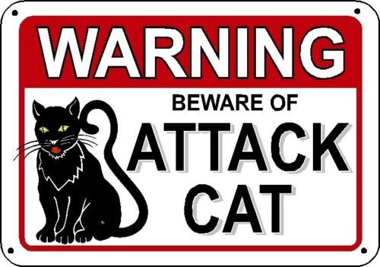
Aggressive Marketers Beware!!!!
It is also reminding Plan Sponsors of one of the primary fiduciary duties, the Prudent Person Rule of ERISA. In his interview with Brian Graff, CEO of the American Retirement Association on June 22, 2022, he reiterated that the obligation of Prudence is a Plan Fiduciaries job and that fiduciaries will need to be prepared to justify any decision to include Crypto in a plan saying “I think it is fair to say that as time goes by I would expect telling people that the issue are Prudence in this and this context is very very real and you need to take it very seriously and think hard about what you're doing here. That means, full analysis weighing all risks such as volatility, recordkeeping concerns and more."
This issue of prudence is very real and like in any other investment decision dealing with retirement plan assets, there isn’t an actual specific set of rules on what will pass muster and what won’t. It’s all facts and circumstances based. This is no different than what they’ve said previously with other “newer” investment ideas such as Private Equity. So, the question for plan fiduciaries is whether participant demand will be sufficient to consider using these funds and then, whether a prudent analysis of Crypto as a potential investment will yield a decision to add them to the plan and then, of course which one??
Let’s not forget that the prudent selection is not a one-time decision, the duty to monitor would also hold. Final thought, plan sponsors may choose to “punt” this plan decision by stewarding participants to use a Self-Directed Brokerage Account (SDBA) as the place to buy these instruments. However, a note of caution here as well. EBSA’s Field Assistance Bulletin 2012 - 02r says that SDBAs are still subject to ERISA 402(a)’s Fiduciary Standard’s of care. This means that the SDBA provider needs to be prudently selected and reasonable boundaries need to be built into the provider to restrict access to imprudent investments (ex. Municipal Securities, Level 2 options, etc.).
OUR TAKE: Over time Crypto may prove to be a viable new asset class OR it may prove to be a fad. I’ve even heard notions of Crypto or its’ underlying technology, blockchain technology, becoming a utility. However, it’s got a lot of uncertainty surrounding it and we would have a very difficult time as plan fiduciaries ourselves in advising a client that they’d be prudent to add to a menu of choices offered in a 401(k) Plan. If you have thoughts on this piece or want to discuss the topic further, please reach out to us!
Jason Grantz is the Managing Director of Institutional Retirement Plans at Integrated Pension Specialists and a Retirement Plan Specialist at Integrated Wealth Concepts. He can be reached at (978) 847-0140 ext. 820 or by email at jason@integrated-pension.com.

